MARS
Technical and Functional Specifications - MR12
Version 1.03
18/12/2015

Written and Approved by:  EUROPEAN DYNAMICS  System Analyst  Christonikos Zonafos,  Vasilis Alexopoulos | Sign off and Date: |  | Appraisal Authority:  EUMS  Key User Representative | Sign off and Date:
Appraisal Authority:  EUROPEAN DYNAMICS  Technical Manager  Dionysios Mantelos | Sign off and Date: |  | Appraisal Authority:  EUMS  Deputy Project Manager | Sign off and Date:
Appraisal Authority:  EUROPEAN DYNAMICS  Project Manager  Tassos Sorilos | Sign off and Date: |  | Appraisal Authority:  EUROPEAN DYNAMICS  Project Manager  Leonidas Savvopoulos | Sign off and Date:
Appraisal Authority:  EUROPEAN DYNAMICS  Quality Assurance Officer  Martin Ulmann | Sign off and Date: |  | Appraisal Authority:  EEAS  Quality Assurance Officer  Roeland Lacroix | Sign off and Date:

document history
Version | Date | Author | Reason for Modification | Action^{(*)} | Confidentiality
0.01 | 12/06/2015 | EUROPEAN DYNAMICS | Creation of Document | C | High
0.02 | 29/06/2015 | EUROPEAN DYNAMICS | Update | U | High
0.03 | 01/07/2015 | EUROPEAN DYNAMICS | Update | U | High
0.04 | 03/07/2015 | EUROPEAN DYNAMICS | Update | U | High
0.05 | 21/08/2015 | EUROPEAN DYNAMICS | Update | U | High
0.06 | 22/09/2015 | EUROPEAN DYNAMICS | Update – Add Subcode Split, Mail To Mars Groups Distribution Lists Integration | U | High
0.07 | 29/09/2015 | EUROPEAN DYNAMICS | Update –  Rename Subcode Split into Distribution Lists Field  Separate and re-write Distribution Lists Integration with Mail to Mars Groups  Add Distribution Lists Enhancements | U | High
0.08 | 07/10/2015 | EUROPEAN DYNAMICS | Update –  EEAS comments applied  Mail to MARS Groups Dedicated Group | U | High
0.09 | 12/10/2015 | EUROPEAN DYNAMICS | MR12 baseline, SSA approved | U | High
0.10 | 16/10/2015 | EUROPEAN DYNAMICS | Update - Official Quote Automation | U | High
0.11 | 23/10/2015 | EUROPEAN DYNAMICS | Update - Official Quote Automation | U | High
1.0 | 30/10/2015 | EUROPEAN DYNAMICS | SSA approved | U | High
1.01 | 06/11/2015 | EUROPEAN DYNAMICS | Update - Official Quote Automation | U | High
1.02 | 30/11/2015 | EUROPEAN DYNAMICS | Update | U | High
1.03 | 18/12/2015 | EUROPEAN DYNAMICS | Update | U | High
(*) Action: C= Creation, I=Insert, U=Update, R=Replace, D=Delete
CIRCULATION LIST
Person Name | Organisation Name
Dionysios Mantelos | EUROPEAN DYNAMICS
Christonikos Zonafos | EUROPEAN DYNAMICS
Vasilis Alexopoulos | EUROPEAN DYNAMICS
Panagiotis Vassilikopoulos | EUROPEAN DYNAMICS
Leonidas Savvopoulos | EUROPEAN DYNAMICS
Tassos Sorilos | EUROPEAN DYNAMICS
Martin Ulmann | EUROPEAN DYNAMICS
Roeland Lacroix | EEAS
Virginia Gonzalez-Ruiz | EEAS
Applicable and REFERENCE documents
Type^{(*)} | Title | Identification | Ver | Date
R1 | D.TFS Technical and Functional Specifications - MR10 | D.TFS Technical and Functional Specifications - MR10 v0.03.doc | 0.03 | 22/10/2014
R2 | D.I Investigation - MR12 | D.I Investigation - MR12 v0.02 | 0.02 | 10/9/2015
R3 | D.TFS Technical and Functional Specifications - MR11 | D.TFS Technical and Functional Specifications - MR11 v0.11.doc | 0.11 | 09/06/2015
X1 | Production Export | Production Export |  | 30/07/2015
(*): Reference document, Applicable document
Table of Contents
1 Introduction 8
2 MAIL TO MARS GROUPS 9
2.1 Analysis 9
2.1.1 MARS_OUTLOOK.dll 10
2.1.2 DM Outlook Integration 12
2.2 Implementation 13
2.3 Documentation 13
2.4 Out of Scope 13
2.4.1 Email Recipients Restrictions 13
3 Distribution Lists Field 14
3.1 Analysis 14
3.1.1 New Profile Field 14
3.1.1.1 MARS Forms 14
3.1.1.2 Webtop 17
3.1.2 Integration with the Existing Implementations 17
3.1.2.1 Distribution Lists 17
3.1.2.2 CDM Transmission Sheet 18
3.1.2.3 Webtop 18
3.2 Implementation 18
3.2.1 Client-Side 18
3.2.2 Server-Side 18
3.3 Documentation 19
3.4 Out of Scope 19
4 Distribution Lists Integration with Mail to Mars Groups 20
4.1 Analysis 20
4.1.1 Mail to Users 20
4.1.2 Mail to Registries 20
4.2 Implementation 20
4.3 Documentation 20
4.4 Out of Scope 20
5 Enhancements on Distribution Lists 21
5.1 Analysis 21
5.2 Implementation 21
5.3 Documentation 21
6 Official Quote Automation 22
6.1 Analysis 22
6.1.1 Request Official Quote 22
6.1.1.1 New 22
6.1.1.2 Suffix 23
6.1.2 Finalize/Update Official Quote 25
6.1.2.1 Finalize Official Quote 26
6.1.2.2 Update Official Quote 26
6.1.3 Weptop – MARS Official Quotes and Closed Lists 29
6.1.4 Weptop – Official Quotes Log 29
6.2 Implementation 31
6.2.1 Client-Side 31
6.2.2 Server-Side 31
6.3 Documentation 32

Table of Figures
Figure 1: Mail to MARS Groups event handler location 10
Figure 2: MARS Groups Select Form 11
Figure 3: MARS Groups Select Form search example 11
Figure 4: DM Outlook Integration 12
Figure 5: MARS_CATAL_DOCPROF Form – Subcode split 16
Figure 6: MARS_CATAL_FOLDPRO Form – Subcode split 16
Figure 7: ADVANCED SEARCH Form – Subcode split 17
Figure 8: Request Official Quote form 23
Figure 9: Official Quote search box 23
Figure 10: Official Quote form 25
Figure 11: Official Quote Status Life-Cycle 28
Figure 12: Official Quotes - Webtop page 29
Figure 13: Official Quotes Log – Webtop page 30

Table of TABLEs
Table 1: Request Official Quote form fields 25
Table 2: Finalize/Update Official Quote form fields 27
Table 3: Official Quote Statuses 28
Table 4: Official Quotes Log – Webtop page fields 29

Introduction
This document contains technical and functional specifications for the MARS system for Maintenance Release 12.
This document also presents the Contractor’s proposal of how these enhancements shall be implemented, aiming to identify and address any problems as early as possible at the inception phase, before their implementation.
Furthermore, the document provides the Contractor’s impact analysis of the change and will be updated with new scope and impact analysis results.
The functional and technical specifications of the targeted changes in MR12 are developed in the remaining chapters of this document, with every change developed in a separate chapter. More chapters will be appended in the document as more changes will be included in MR12.

MAIL TO MARS GROUPS
A new functionality is required, allowing MARS Users to send emails to one or more MARS User Groups via MS Outlook 2003. In order for this functionality to be added, the following actions need to be available:
- A new .NET event handler DLL providing a windows form which will contain the active MARS Groups and will be able to copy the Users’ mail addresses from a selected set of Groups (one or more) to the system clipboard. A user will then be able to paste the addresses to the “To”, “Cc” or ”Bcc” fields of a MS Outlook 2003 New Mail Item.
- A new button integrated to MS Outlook 2003 utilizing the above .NET event handler DLL functionality implemented as a COM Add-in.

Analysis
The new functionality will be able to provide the user names of one or more Mars Users Groups in order to give a User the means to paste them in the “To”, “Cc” or ”Bcc” field of a MS Outlook 2003 mail message. After pasting the user names to the necessary mail message field(s) the Exchange Server will be responsible to translate the given names to email addresses.
The new functionality will be implemented as a new event handler, providing a form which will contain all the available Mars Users Groups. By selecting one or more Groups, user names will be automatically copied to the system clipboard ready to be pasted in the “To”, “Cc” or ”Bcc” field of a MS Outlook 2003 mail message.

MARS_OUTLOOK.dll
A new event handler will be introduced providing a User with a form containing all the MARS Groups. By selecting one or more groups and pressing a specified button, the handler will copy to the system clipboard a string containing the active users’ full names of the selected group(s) in the following format: {Full Name for FirstUser};{ Full Name for SecondUser};...{ Full Name for LastUser} ready to be pasted into either “To”, ”Cc” or “Bcc” fields of MS Outlook 2003 mail message form. After pasting the copied selection into the fields above, Full Names will be automatically resolved to email addresses via the Exchange Server functionality (outside of MARS).
The new event handler will be accessible via Options→Mail to Mars Groups, Menu selection of the DM Explorer main window. Moreover, a new MARS Group will be created (MARS_MAIL), the users of which will be the only ones with this new action available. The Group MARS_MAIL will have Universal Access = “None”.
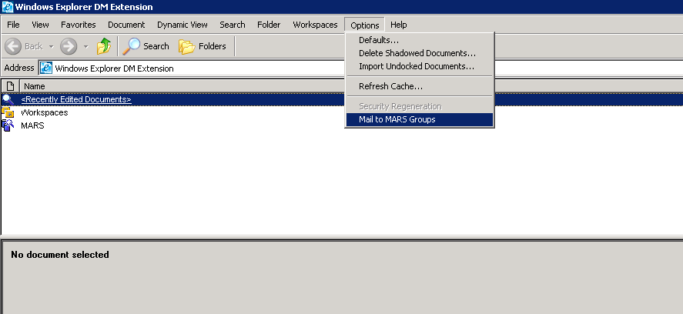
Figure 1: Mail to MARS Groups event handler location
A User will be able to select one or more groups from the described form. A select all/deselect all checkbox will be provided in order to ease this procedure.
Furthermore, Users will be able to filter groups by providing a search string (according to their needs) and pressing a corresponding button (Search button). When the focus is on the search textbox, Users will be able to press the “Enter” button to perform the search operation (equivalent to clicking the “Search” button).
Every provided search string will be queried against the database as a LIKE clause hence the returned results will include any Group starting with, containing or ending with the provided string. Using this approach we can implement a flexible functionality providing the means for generalizing or narrowing down the anticipated results.
Navigation through the Form’s controls can be also performed by using the “Tab” button, ordered from left to right and then down left (left to right reading).

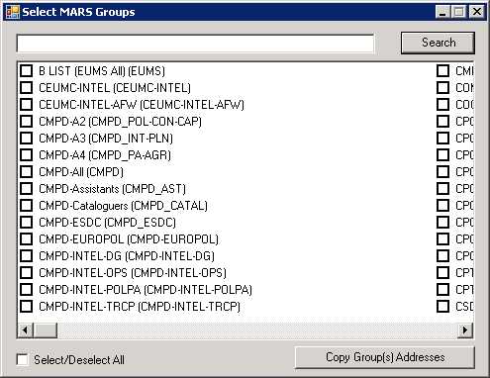
Figure 2: MARS Groups Select Form
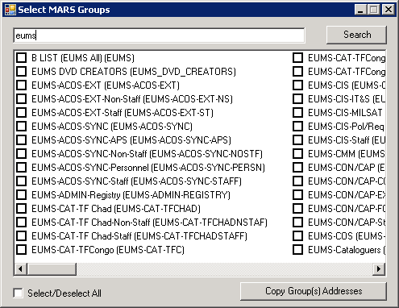
Figure 3: MARS Groups Select Form search example

DM Outlook Integration
A new button will be introduced, located in the Outlook 2003 main explorer command bar, utilizing the already described Event Handler functionality.

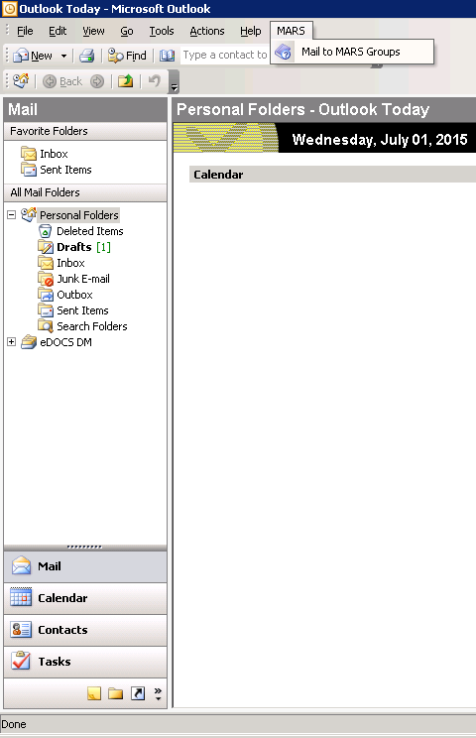
Figure 4: DM Outlook Integration

Implementation
The solution will be integrated in the MR12 automated Client Installation scripts. More specifically:
- The new .NET event handler DLL MARS_OUTLOOK.dll will be copied automatically under “C:\Program Files\Open Text\DM Extensions” and registered under the key “HKEY_LOCAL_MACHINE\SOFTWARE\Hummingbird\PowerDOCS\OM\EventHandlers\ MARS_OUTLOOK”.
The new event handler will be accessible via Options→Mail to Mars Groups Menu selection of the DM Explorer main window.
- For the Outlook Integration a new Outlook 2003 COM add-in will be implemented, utilizing the .NET event handler. The new add-in will be installed under “C:\Program Files\European Dynamics SA\MARS Outlook Integration Addin\”.
- For the Distribution Lists Integration, the .NET event handlers DLL MARS_OUTLOOK.dll and DistributionLists.dll will be modified.
Moreover, the solution will include the SQL script that will create the required MARS group MARS_MAIL, which EEAS Administrators have to execute manually before installing the MARS Mail to Groups functionality on a MARS client.

Documentation
The following documentation will be updated, covering the new functionality:
- Consolidated Requirements Specifications
- Installation Manual for client side installation
- Software Design
- User Manual
- Use Cases
- Test Cases

Out of Scope
The user must be connected to MARS with the DM. If the connection is lost, these functionalities won’t work.

Considering that the scope of this implementation is more generic, not adding a document-specific action, logging into the Document History and/or the History logs is redundant. In fact, logging the selection of groups and retrieval of users is not necessary, as it falls under the philosophy of any document or closed-list retrieval in MARS, which are non-logged actions.

Email Recipients Restrictions
By default Outlook 2003 does not apply any restrictions to the number of addresses typed/pasted in a “To”, “Cc” or ”Bcc” fields.
In Exchange Server 2003 the default value for the maximum number of recipients is 5000.
The Exchange Server Administrators are responsible for applying and managing any further restrictions/permissions.

Distribution Lists Field
The Subcode field on Document Profile has been used for storing not only Subcodes, but also Codes for the Distribution Lists and their related Security Rules. As such, it is required that Subcode is split into two distinct fields (Subcode and Distribution Lists), each one serving a different business purpose.
In order for this to be implemented, the following actions need to be done:
- A new database Profile field will be introduced, also reflected into the relevant Profile Forms and Webtop pages.
- The previously implemented functionality will be reviewed so that the new field is introduced where needed.

Analysis
The following actions are required:
- Introduction of a new Profile field.
- Integration into the existing implementations.

New Profile Field

MARS Forms
For the Profile forms MARS_CATAL_DOCPROF and MARS_CATAL_FOLDPRO, along with the ADVANCED SEARCH form, the existing Subcode field will be renamed into “Distribution Lists”, while a new “Subcode” field will be added. For both Profile forms, “Distribution Lists” and the new “Subcode” field will be optional. In all other respects, the process of managing a document/folder profile and performing a search will remain unchanged.
The values that will remain under the “Distribution Lists” field will be those containing in their name “DL-“ or “INTEL”, along with the following explicit ones: "CPCC", "CHAD", "SOMALIA", "EUTRA SOMALIA", "CMPD", "GSC", "CPT-CAR" and "INT-PRD". Based on X1, this translates into the following values:

CEUMC-INTEL
CEUMC-INTEL-AFW
CHAD
CMPD
CMPD-INTEL-DG
CMPD-INTEL-OPS
CMPD-INTEL-POLPA
CMPD-INTEL-TRCP
CPCC
CPCC-INTEL
CPCC-INTEL-AFW
CPT-CAR
CUE-DL-AFRICA CENTRAL
CUE-DL-AFRICA HORIZONTAL
CUE-DL-AFRICA HORN
CUE-DL-AFRICA SOUTHERN
CUE-DL-AFRICA WEST
CUE-DL-ASIA AF PAK
CUE-DL-ASIA CHINA
CUE-DL-ASIA HORIZONTAL
CUE-DL-ASIA INDIAN SUBCONTINENT
CUE-DL-ASIA KOREA FAR EAST
CUE-DL-ASIA PACIFIC
CUE-DL-ASIA SOUTH EAST
CUE-DL-CLIMA
CUE-DL-COUNTER PROLIFERATION
CUE-DL-COUNTER TERRORISM
CUE-DL-CYBER
CUE-DL-ECA CENTRAL ASIA
CUE-DL-ECA NEIGHBOURHOOD
CUE-DL-ECA RUSSIA
CUE-DL-ECA TURKEY
CUE-DL-ECA WESTERN BALKANS
CUE-DL-ENERGY
CUE-DL-HUMANITARIAN
CUE-DL-ISB
CUE-DL-LA HORIZONTAL
CUE-DL-LA MEXICO_CENTRAL AMERICA_CARIBBEAN
CUE-DL-LA SOUTH AMERICA
CUE-DL-MANAGING DIRECTORS
CUE-DL-MENA ARABIAN PENINSULA
CUE-DL-MENA HORIZONTAL
CUE-DL-MENA IRAN
CUE-DL-MENA MAGHREB
CUE-DL-MENA MASHREQ
CUE-DL-MENA MEPP ISRAEL PALESTINE
CUE-DL-MENA SYRIA-IRAQ
CUE-DL-MIGRATIONS
CUE-DL-POLICY COORDINATION
CUE-DL-SATCEN
CUE-DL-SECURITY
CUE-DL-THREAT ASSESSMENTS
EU SATCEN-INTEL
EU SITROOM-INTEL
EU SITROOM-INTEL-AFW
EUMS-INTEL
EUMS-OPS-MAP-INTEL
EUMS-OPS-WKC-INTEL
EUTM-BSC-INTEL-AFW
EUTRA SOMALIA
GSC
INT-PRD
OPCEN-INTEL
RUE-DL-AFRICA CENTRAL
RUE-DL-AFRICA HORIZONTAL
RUE-DL-AFRICA HORN
RUE-DL-AFRICA SOUTHERN
RUE-DL-AFRICA WEST
RUE-DL-ASIA AF PAK
RUE-DL-ASIA CHINA
RUE-DL-ASIA HORIZONTAL
RUE-DL-ASIA INDIAN SUBCONTINENT
RUE-DL-ASIA KOREA FAR EAST
RUE-DL-ASIA PACIFIC
RUE-DL-ASIA SOUTH EAST
RUE-DL-CLIMA
RUE-DL-COUNTER PROLIFERATION
RUE-DL-COUNTER TERRORISM
RUE-DL-CYBER
RUE-DL-ECA CENTRAL ASIA
RUE-DL-ECA NEIGHBOURHOOD
RUE-DL-ECA RUSSIA
RUE-DL-ECA TURKEY
RUE-DL-ECA WESTERN BALKANS
RUE-DL-ENERGY
RUE-DL-HUMANITARIAN
RUE-DL-ISB
RUE-DL-LA HORIZONTAL
RUE-DL-LA MEXICO_CENTRAL AMERICA_CARIBBEAN
RUE-DL-LA SOUTH AMERICA
RUE-DL-MANAGING DIRECTORS
RUE-DL-MENA ARABIAN PENINSULA
RUE-DL-MENA HORIZONTAL
RUE-DL-MENA IRAN
RUE-DL-MENA MAGHREB
RUE-DL-MENA MASHREQ
RUE-DL-MENA MEPP ISRAEL PALESTINE
RUE-DL-MENA SYRIA-IRAQ
RUE-DL-MIGRATIONS
RUE-DL-POLICY COORDINATION
RUE-DL-SATCEN
RUE-DL-SECURITY
RUE-DL-THREAT ASSESSMENTS
SOMALIA

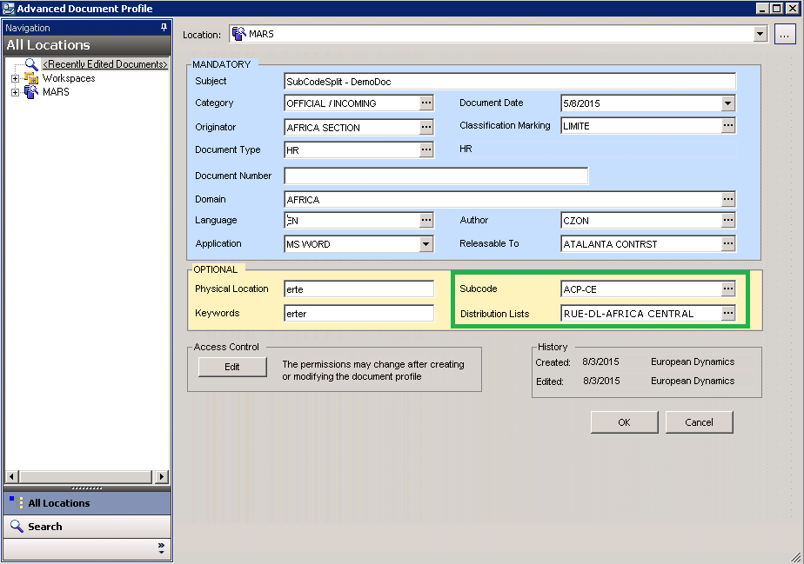
Figure 5: MARS_CATAL_DOCPROF Form – Subcode split

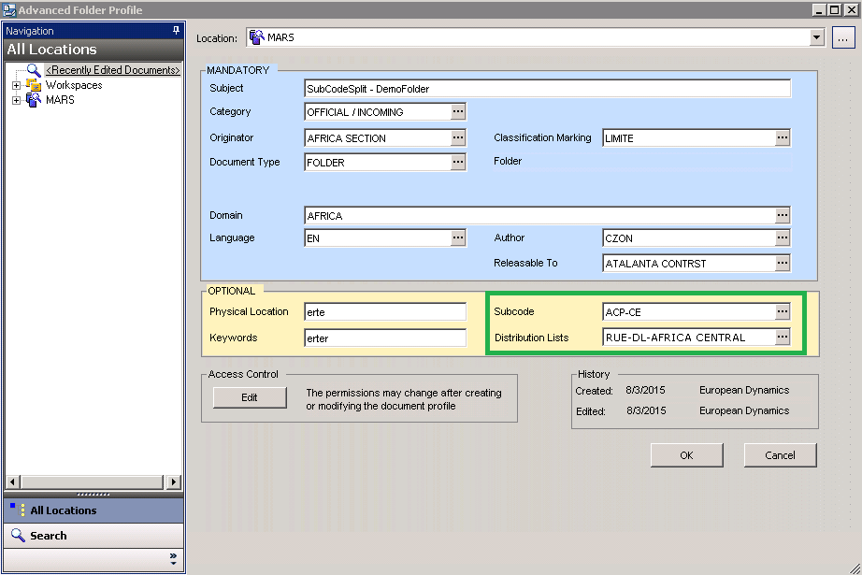
Figure 6: MARS_CATAL_FOLDPRO Form – Subcode split

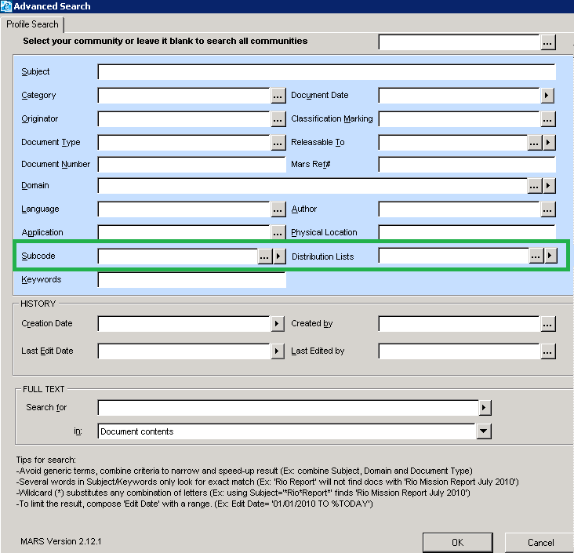
Figure 7: ADVANCED SEARCH Form – Subcode split

Webtop
On Webtop, under DM Admin > Validation Tables > Other Tables, “MARS Subcodes” will be renamed into “MARS Distribution Lists – Subcodes” and a new “MARS Subcodes” will be introduced, referring to the new field MARS_SUB_CODE_CLR.

Integration with the Existing Implementations
The Subcode split affects directly the implementation of the Distribution Lists and the CDM Transmission Sheet. In both cases, the user experience will not be affected. On the Webtop side, one ASP page is affected. Finally, The synchronization scripts should be enhanced, so that the new table MARS_SUB_CODE_CLR is synchronized along with MARS_SUB_CODE.

Distribution Lists
For the Distribution Lists, the change affects the process followed when a new Distribution List inherits the metadata of its parent folder. In order for this to be done, DistributionLists.dll will have to be updated.
This change will be tested by executing Test Case TC-MR11-20 of R1.

CDM Transmission Sheet
The Transmission Sheets generated for CDM contain the information “CDM Acronyms”, which is currently linked to the Keywords Profile field. This will change so that it is mapped to the “Subcode” Profile field. In order for this to be done the following files will have to be updated:
- TransmissionSheet.dll
- TransmissionSheetTemplate_CDM_C.docx
- TransmissionSheetTemplate_CDM_R.docx
This change will be tested by executing Test Cases TC-MR11-28, TC-MR11-29, TC-MR11-30 of R1.

Webtop
On the Webtop, mars_searchByCatal.asp will be updated so that the Document search retrieves the new field MARS_SUB_CODE_CLR in addition to the old ones.

Implementation

Client-Side
The solution will be integrated into the MR12 automated Client Installation scripts. More specifically:
- The .NET event handler DLLs DistributionLists.dll and TransmissionSheet.dll will be copied automatically under “C:\Program Files\Open Text\DM Extensions”, replacing the existing ones.
- The template files TransmissionSheetTemplate_CDM_C.docx and TransmissionSheetTemplate_CDM_R.docx will be copied automatically under the Word Application Data trusted location of each user, replacing the existing ones.

Server-Side
The solution will include an SQL script which EEAS Administrators have to execute manually. This script will:
- Change the Description of the existing MARS_SUB_CODE lookup and the existing MARS_SUB_CODE form into “Distribution Lists”.
- Create a new closed list for the new Subcode (Create the MARS_SUB_CODE_CLR table).
- Create the MARS_SUB_CODE_CLR lookup and the MARS_SUB_CODE_CLR form with Description “Subcode”.
- Edit the PROFILE table, adding the additional field MARS_SUB_CODE_CLR (varchar2(250), Nullable).
- Update in FORMS table the entries for MARS_CATAL_DOCPROF, MARS_CATAL_FOLDPRO and ADVANCED SEARCH in order to add the new Subcode field.
- Move the entries not related with the Distribution Lists from table MARS_SUB_CODE to table MARS_SUB_CODE_CLR.
- Move all the Profile entries related to the MARS_SUB_CODE_CLR table contents from the MARS_SUB_CODE_MUL to the MARS_SUB_CODE_CLR Profile field.

Note that the existing MARS_SUB_CODE has its description changed into “Distribution Lists” (instead of adding a new one called “Distribution Lists”) so that the Security Rules tied to it can continue to apply without having to temper with them.
In addition to the SQL script, the solution will include mars_searchByCatal.asp Webtop page, to be manually copied under the LibMain folder of the website.

Documentation
The following documentation will be updated, covering the new Profile field functionality:
- Consolidated Requirements Specifications
- Installation Manual for server side installation
- Software Design
- Data Dictionary
- Database Relationship Model
- Security Model
- Document Administrator Manual
- User Manual
- Test Cases
- Non-regression Test Cases
- Training Material.

Out of Scope
Security Rules will continue to apply in relation to the values of the MARS_SUB_CODE table. Adding or modifying rules to take into account the values of MARS_SUB_CODE_CLR table is considered out of scope for this solution.

Distribution Lists Integration with Mail to Mars Groups
Having performed the addition of the Distribution Lists information on the Profile of each document (3.1.1), the automation for retrieving the emails of the users belonging to a Distribution List is required to be added for the Distribution of a document.

Analysis

Mail to Users
The process of distribution will not change in relation to what is described in R3 (2.1.3.1.1 – Mail to Owners). In addition to all the existing steps, Mail to Owners will now also be addressed (in the “To” field of the email) to all the MARS users belonging to the Distribution Lists defined under the Distribution Lists field of the profile of the Master document. These users will be in addition to the MARS users defined in the Additional Distribution List fields of the Distribution document. All the emails will appear only once, even if a MARS user is referred by more than one List/ source.
Moreover, the email will also be sent as a copy (the “CC” field of the email) to the users belonging to the EUMS-Subregistry and the EEAS Central EUCI REG groups.

Mail to Registries
The process of distribution will not change in relation to what is described in R3 (2.1.3.1.2 – Mail to Registries). In addition to all the existing steps, Mail to Registries will now also be sent as a copy (the “CC” field of the email) to the users belonging to the DL-EUMS-INT-DMC group.

Implementation
The solution will be integrated in the MR12 automated Client Installation scripts. More specifically:
- The existing .NET event handler DistributionLists.dll will be copied automatically under “C:\Program Files\Open Text\DM Extensions”, replacing the existing implementation.

Documentation
The following documentation will be updated, covering the new functionality:
- Consolidated Requirements Specifications
- Installation Manual for client side installation
- Software Design
- User Manual
- Use Cases
- Test Cases

Out of Scope
The user must be connected to MARS with the DM. If the connection is lost, these functionalities won’t work.

Enhancements on Distribution Lists
It is required that a series of dialogs are displayed, guiding the user through the steps performed when distributing a document from a Distribution List document.

Analysis
For both Simple and Full (BIC) Distribution List Generation (R3, 2.1.3.1 & 2.1.3.2), when clicking “Distribute”, the steps will be altered as follows:
  - A dialog box appears, with the information “An E-Mail to Users will be generated. Continue?” and the choices “Next”, “Skip”, “Cancel”.
Button | Action
Next | The process continues normally to Step 2.
Skip | The mail is not generated and the process continues directly to Step 3.
Cancel | The Distribution process is aborted.

  - The mail is generated, as described in R3 (2.1.3.1.1 – Mail to Owners).
  - A dialog box appears, with the information “An E-Mail to Registries will be generated. Continue?” and the choices “Next”, “Skip”, “Cancel”.
Button | Action
Next | The process continues normally to Step 4.
Skip | The mail is not generated and the process is terminated.
Cancel | The Distribution process is aborted, effectively having the same behaviour as “Skip”.

  - The mail is generated, as described in R3 (2.1.3.1.2 – Mail to Registries).

Implementation
The solution will be integrated in the MR12 automated Client Installation scripts. More specifically:
- The existing .NET event handler DistributionLists.dll will be copied automatically under “C:\Program Files\Open Text\DM Extensions”, replacing the existing implementation.

Documentation
The following documentation will be updated, covering the new functionality:
- Consolidated Requirements Specifications
- Installation Manual for client side installation
- Software Design
- User Manual
- Use Cases
- Test Cases

Official Quote Automation
A new functionality is required, allowing MARS Users to automatically generate an Official Quote for each official outgoing document. The request for this automation derives from the need to eliminate syntax errors, to centralize and simplify the overall procedure. In order for this functionality to be added, the following actions need to be available:
- A new .NET event handler DLL (top-level action) providing a windows form that will handle the request for a new Official Quote.
- A new .NET event handler DLL (document-level action) providing a windows form that will handle the assignment of an obtained Official Quote to the document.
- New Closed Lists, allowing the EEAS Document Administrators to manage the Official Quote requests, the Official Quote Ranges and Keywords.
- A Webtop page, allowing the EEAS Document Administrators to audit the Official Quote logs.

Analysis
The following will allow for the automation of generating an Official Quote:
- A new action (Request Official Quote) that will allow for a new Official Quote to be created.
- A new action (Finalize/Update Official Quote) that will allow relating an Official Quote with the selected document.
- New Closed Lists (MARS Official Quotes, MARS Official Quotes Ranges, MARS Official Quotes Keywords, MARS Official Quotes Statuses), that will allow the EEAS Document Administrators to perform update actions to the Official Quotes and the relevant closed lists.
- A new Webtop page (Official Quotes Log) that will allow the EEAS Document Administrators to inspect all the logged information concerning the Official Quotes.

Request Official Quote
A new action – Request Official Quote - will be added under the Options menu in DM Extensions. This new action will be a new .NET event handler DLL. Selection of the Request Official Quote action will launch a prompt, allowing the user to select “New” (to request a New Official Quote) or “New Suffix” (to request an Official Quote based on an existing one).
Moreover, a new MARS Group will be created (MARS_OFF_QUOTE), the users of which will be the only ones with this new action available. The Group MARS_OFF_QUOTE will have Universal Access = “None”.

New
Selecting “New”, the Request Official Quote form (Figure 8) appears having the “Number” field pre-filled with the next available value and the “Suffixes” fields disabled. This action automatically reserves the current Number, logging the id of the user making the request and the timestamp of this request. This is happening automatically so no two users can request the same number simultaneously.
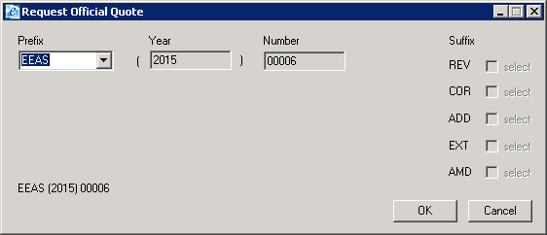
Figure 8: Request Official Quote form
After filling the mandatory fields (Table 1) and clicking OK, the new Official Quote is confirmed and its status becomes Requested. Clicking Cancel or exiting the form releases the current Number for further use. Moreover when clicking OK a dialog appears informing the user that the Official Quote text will be copied to clipboard for further use.

Suffix
Selecting “New Suffix” (Suffixes are COR, ADD, REV, EXT and AMD), a search box appears (Figure 9), allowing the user to search for and select an existing Official Quote. The Quotes displayed are the latest iterations of each Official Number Finalized by all the users with the same Originator as the current user. This is to ensure that the users of the same Directory will all have access to the same Official Quotes. The search box will have similar functionality with Open Text’s default search box, with the exception of the “Recently used items”, that are not needed for Official Quote.
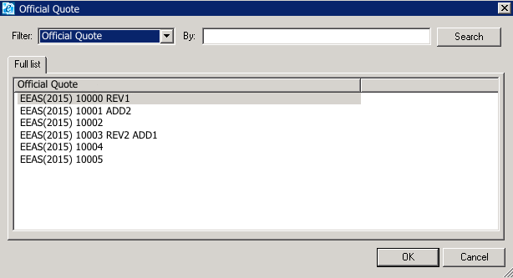
Figure 9: Official Quote search box
On OK, the Request Official Quote form (Figure 8) appears, having the “Suffixes” fields enabled. The user can thenscheck a specific required Suffix value.
The rule preceding a Suffix value selection is:
- A corrigendum will not be available for the INIT version of a Suffix Official Quote. For example:
  - Having an existing quote EEAS (2015) 0010, COR checkbox will be disabled.
  - Having an existing quote EEAS (2015) 0010 REV 1, COR checkbox will be enabled.
The rule following a Suffix value selection, is:
    - The earliest in order of REV/ COR/ ADD/ EXT/ AMD supersedes the rest. This means that when a suffix is increased, those next in the order are initialized. For example:
  - Having an existing quote EEAS (2015) 0010 REV1 ADD2, getting a new REVision would result into EEAS (2015) 0010 REV2.
  - Having an existing quote EEAS (2015) 0015 REV1 COR2 ADD3, getting a new CORrection would result into EEAS (2015) 0015 REV1 COR3.
  - Having an existing quote EEAS (2015) 0020 REV1 COR2 ADD3 EXT4, getting a new ADDition would result into EEAS (2015) 0020 REV1 COR2 ADD4.

Clicking OK, the Official Quote is reserved and confirmed, logging the id of the user making the request and the timestamp of this request, while its status becomes Requested. Cancel or exiting the form closes the form storing nothing. Moreover when clicking OK a dialog appears informing the user that the Official Quote text will be copied to clipboard for further use.
 |  | New |  | Suffix
Field Name | Mandatory | Enabled | Value | Enabled | Value
Prefix | Yes | Yes | HR / HR-COM / EEAS / EEAS-COM / ADMIN  Default value: EEAS | No | Filled with the value of the selected Quote.
Year | Yes | No | Current Year | No | Filled with the value of the selected Quote.
Number | Yes | No | Next available Official Quote number | No | Filled with the value of the selected Quote.
Suffix - REV | No | No | Empty | Yes | Filled with the value of the selected Quote.
Suffix – COR | No | No | Empty | Yes | Filled with the value of the selected Quote.
Suffix – ADD | No | No | Empty | Yes | Filled with the value of the selected Quote.
Suffix – EXT | No | No | Empty | Yes | Filled with the value of the selected Quote.
Suffix – AMD | No | No | Empty | Yes | Filled with the value of the selected Quote.
Table 1: Request Official Quote form fields
If needed, an EEAS Document Administrator can change the status of a Requested Quote to Available, making it again available for New.

Finalize/Update Official Quote
A new action – Finalize/Update Official Quote - will be added for all types of documents, available in DM Extensions on the right-click menu and under the Document menu. If more than one Document is selected, then the action will be disabled (grayed-out). This new action will be a new .NET event handler DLL. As for Requesting a Quote, only the users of “MARS_OFF_QUOTE” group will have this new action available.
In order for a user to be able to perform the Finalize/Update Official Quote action, it is required that:
    - The user has at least View/Edit Profile and View Document Content access rights on the document.
    - The document has Confidential or Secret classification.
    - The document belongs to an Official category.
Selection of the Finalize/Update Official Quote action will launch the Official Quote form (Figure 10). If the selected document doesn’t have an assigned Official Quote, the form will open to Finalize, otherwise it will open for Update.
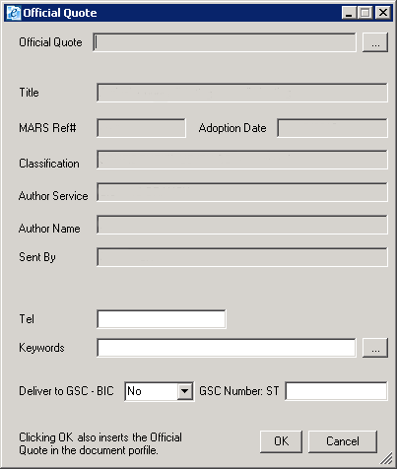
Figure 10: Official Quote form

Finalize Official Quote
When Finalizing an Official Quote the user associates an already requested Official Quote (see 6.1.1) with the selected document. All the fields that are derived from the document’s profile are prefilled and disabled, while the user has to select an Official Quote (via a search box - Figure 9 - displaying only the Requested Quotes available to the user’s Originator), and fill the fields “Tel”, “Keywords”, “Delivered to GSC – BIC” and “GSC St No”, as detailed in Table 2.
Clicking OK, the Official Quote is linked to the document, its status changes to Finalized and the form exits. A linked Quote is no longer available for Finalizing other documents. Cancel or exiting the form closes the form storing nothing. Moreover the Document Profile Document Number will be updated with the Official Quote number, followed by the previously existing contents, in the form "###### - Content". Any characters exceeding the maximum allowed length will be trimmed from the end of the string.
The action of Finalizing an Official Quote is logged in the Document History and in the History Log, labeled “Official Quote Finalized”.

Update Official Quote
Update allows the user to modify only the fields “Tel”, “Keywords”, “Delivered to GSC – BIC” and “GSC St No”. Clicking OK, the Official Quote information is updated. Cancel or exiting the form closes the form storing nothing.
The action of Updating an Official Quote will be logged in the Document History and in the History Log, labeled “Official Quote Updated”.

Field Name | Mandatory | Enabled | Value | Value from Profile
Official Quote | Yes | Finalize: Yes  Update: No | List of values available to Originator
Title | Yes | No |  | Subject
MARS Ref# | Yes | No |  | MARS Ref#
Adoption Date | Yes | No |  | Document Date
Classification | Yes | No |  | Classification Marking
Author Service | Yes | No |  | Originator
Author Name | Yes | No |  | Author
Sent By | Yes | No |  | Created By
Tel | Yes | Yes | free text
Keywords | Yes | Yes | List of values, single selection
Delivered to GSC - BIC | Yes only if “GSC Number: ST” is filled. | Yes | Yes/No
GSC Number: ST | No | Yes | Numeric text.  Saved only if “Delivered to GSC – BIC” = Yes
Table 2: Finalize/Update Official Quote form fields

The available Statuses for an Official Quote are:
Status | Details
Processing | During New
Available | After New and Cancel.  After EEAS Document Administrator’s action on an idle Requested.
Requested | After New and OK  After Suffix. and OK
Finalized | After Finalize and OK
Table 3: Official Quote Statuses
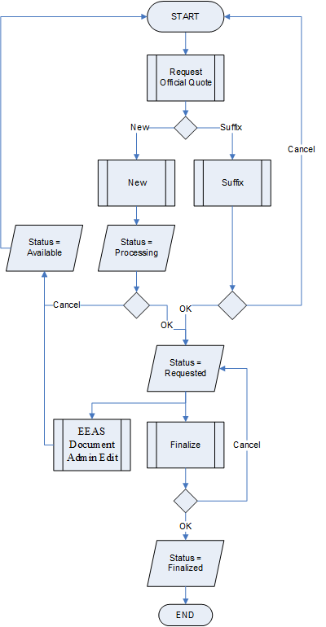
Figure 11: Official Quote Status Life-Cycle

Weptop – MARS Official Quotes and Closed Lists
New Closed Lists will be created and be accessible via Webtop under Validation Tables -> Other Tables for each of the new tables related to the Official Quotes implementation (MARS Official Quotes, MARS Official Quotes Ranges, MARS Official Quotes Keywords). These will allow the EEAS Document Administrators to edit all the table fields, as per all the MARS tables managed in Webtop.
Especially for Mars Official Quotes, the page (Figure 12) will have the added functionality of exporting to xls, producing a report of all the Official Quotes displayed under the results of the form. The XLS produced will have the exact same columns displayed in the page.
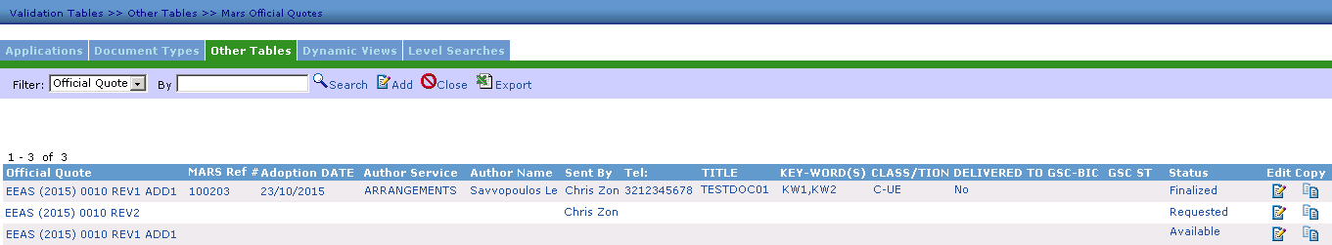
Figure 12: Official Quotes - Webtop page

Weptop – Official Quotes Log
A new Webtop page will be created under Log Pages, displaying all the actions logged (New/Edit) in relation to Official Quotes.
The fields to be displayed are:
Field Name | Description
Date/Time | Date/Time of the action
Mars Ref# | The MARS Reference Number of the related document (if the Quote is Finalized)
Official Quote | The full Official Quote  [Prefix]([Year]) ##### [Suffixes]
Action | REQUEST/FINALIZE/RELEASE
User ID | The user that performed the action.
Event Details | The record state before the update.
Table 4: Official Quotes Log – Webtop page fields
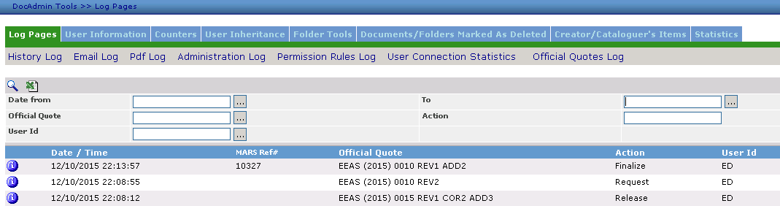
Figure 13: Official Quotes Log – Webtop page

Implementation

Client-Side
The solution will be integrated in the MR12 automated Client Installation scripts. More specifically:
- The new .NET event handler DLL ReqQuote.dll will be copied automatically under “C:\Program Files\Open Text\DM Extensions” and registered under the key “HKEY_LOCAL_MACHINE\SOFTWARE\Hummingbird\PowerDOCS\OM\EventHandlers\ReqQuote”.
- The new .NET event handler DLL MngQuote.dll will be copied automatically under “C:\Program Files\Open Text\DM Extensions” and registered under the key “HKEY_LOCAL_MACHINE\SOFTWARE\Hummingbird\PowerDOCS\OM\EventHandlers\MngQuote”.

Server-Side
Moreover, the solution will include a Webtop Installation Package and an SQL script.
EEAS Administrators have to copy the Webtop files to the location that will be specified in the Installation Manual and execute the SQL script manually before installing this functionality on a MARS client.
The script will:
- Create new closed lists
  - for Official Quote Status (Create and populate the MARS_OFFICIAL_QUOTE_STATUS table).
  - for Official Quote Keywords (Create and populate the MARS_OFFICIAL_QUOTE_KEYWORDS table).
  - for Official Quote Keywords (Create and populate the MARS_OFFICIAL_QUOTE_RANGE table).
- Create the lookups and forms for the closed lists
  - MARS_OFFICIAL_QUOTE_STATUS lookup and MARS_OFFICIAL_QUOTE_STATUS form.
  - MARSOFFICIAL_QUOTE_KEYWORDS lookup and MARS_OFFICIAL_QUOTE_KEYWORDS form.
  - MARS_OFFICIAL_QUOTE _KEYWORDS lookup and the MARS_OFFICIAL_QUOTE_RANGE form.
- Create the new MARS_OFFICIAL_QUOTE table.
- Create the MARS_OFFICIAL_QUOTE lookup and the MARS_OFFICIAL_QUOTE form.

Documentation
The following documentation will be updated, covering the new Official Quotes functionality:
- Consolidated Requirements Specifications
- Installation Manual for client side installation
- Installation Manual for server side installation
- Software Design
- Data Dictionary
- Database Relationship Model
- Security Model
- Document Administrator Manual
- User Manual
- Test Cases
- Training Material

According to Item 133 SIAC Lists implementation
Based on Microsoft documentation (KB 265203)

